Nama : Intan Azizah Putri

Kelas : Data Engineer Batch 8

1. Upload the data into BigQuery Table (Hands on: Exercise)

1. Build table dim_fulfilment using DBT (Hands on: Exercise)

1. Build table dim_product using DBT (Hands on: Exercise)

1. Build table dim_promotion using DBT

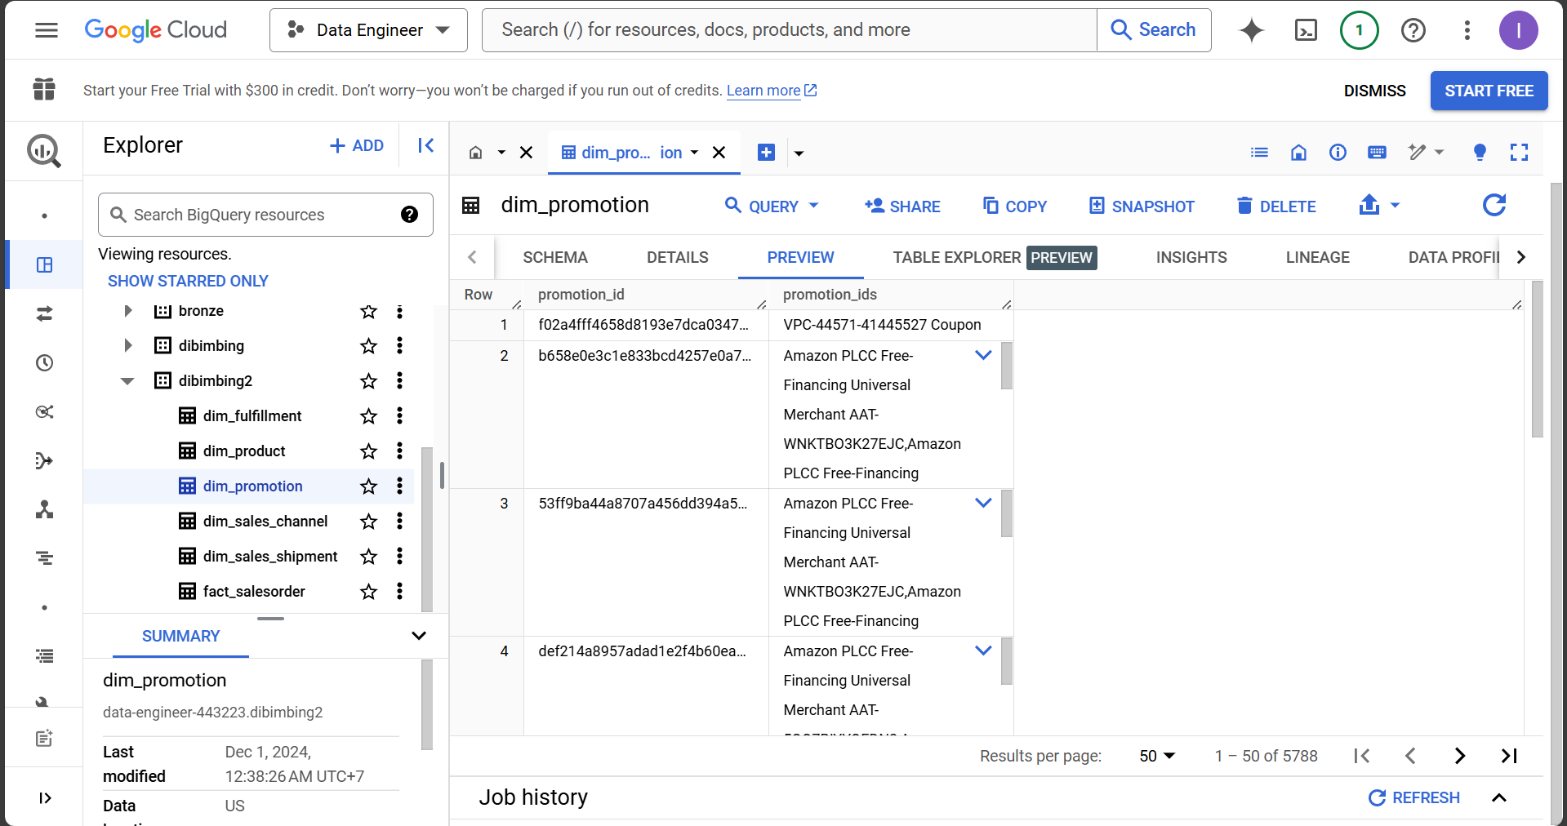

1. Build table dim_sales_shipment using DBT

1. Build table dim_sales_channel using DBT

1. Build table fact_salesorder using DBT

1. Create an ERD for the Star Schema

1. Create an Analysis using Star Schema ex Top Selling Products etc

Top 5 Sales by Promotion

